Fairwell android To-do list Rev.1

Prepared by: Issac October 25, 2015

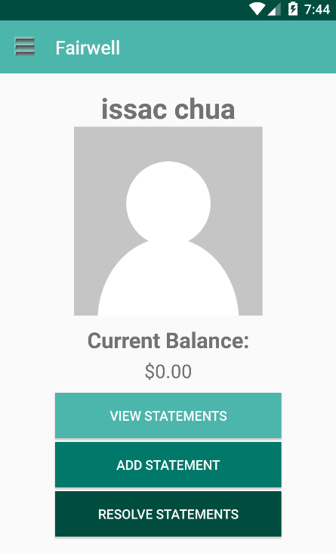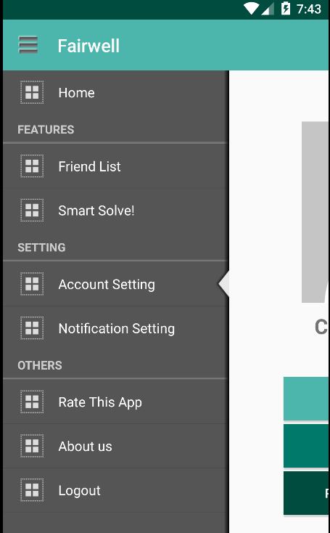

# Main screen

This UI will be most likely the finalized design for Fairwell, unless there is any huge update or change throughout the course. We will go over each section one by one.

# Friend list

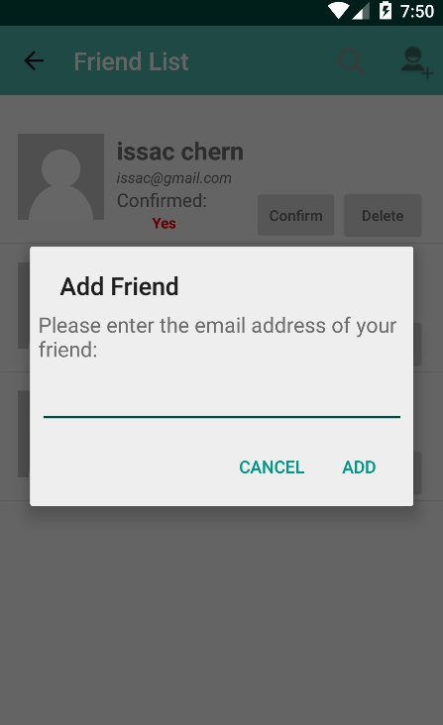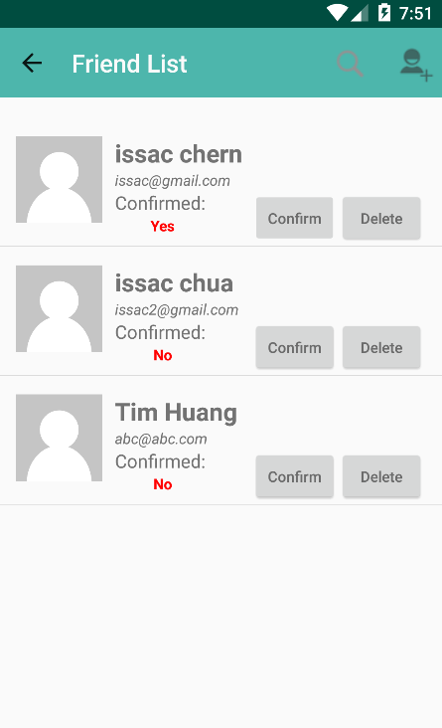

In the friend list (left), we have search button and add friend button on Action bar. It shows a list of friends (those are already friends and those are still waiting for confirmation). When clicking the add friend button, a dialog will be popped out requesting for the email address of your friend (right).

**To-do list:**

1. Implement the search box  on Action bar in FriendsActivity to search for a specific person. When clicking the person, display a dialog showing the debt amount in between you and the person.
2. While waiting for a friend’s approval, the “confirm” button shouldn’t appear in requester’s account.   
     
     
     
     
     
     
   Once the friend request is accepted, the “Awaiting friend request” text and “confirm” button should be disappeared. When the person is not your friend yet, clicking “delete” button will display a dialog about deleting the request. Otherwise, it will display a dialog about deleting the friend.

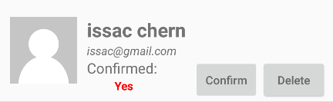

Awaiting friend request

1. Sort the friend list alphabetically.

# smart solve!

**To-do list:**

1. Smart Solve handles multiple users’ debt all at once. A simple scenario: If you owe A $10 and A owes B $10. Smart Solve algorithm will tell you to pay B $10 directly, reducing the number of transaction. It is now an option in the side panel.
2. In order to use Smart Solve, the person you choose must be friends with each other. If one is not a friend of others, then Smart Solve will deny the process and request the user to re-select.

# Account setting

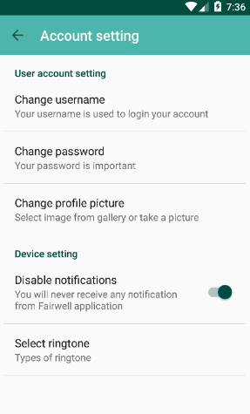**T****o-do list:**

1. In account setting, the user can change his/her username, password and profile picture as well.
2. Disable notification means you will not receive any notification from this app, whether a statement has been settled or someone added you as a friend.
3. Select ringtone for incoming notification. (optional)
4. This is just a basic outline for account settings. We will add whatever that fits in this section later on.

# Notification setting

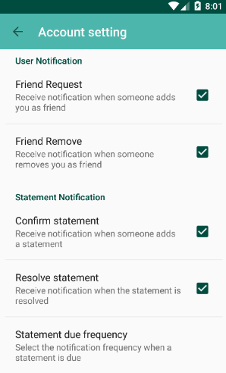**To-do list:**

1. 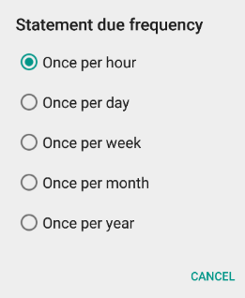Select how the notification should be transmitted. All the checkboxes are set by default, but the user can change how they should receive the notification from Fairwell.
2. Statement due frequency: basically when the due date is up, you can choose how frequently Fairwell should send the “reminder” notification to the party members, it could be as annoying as once per hour, or once per year. (Will remove this option if it seems to be unnecessary)

# rate this app and about us

“Rate this app” will bring the user to the Fairwell app on Google Play (when the app is ready to be published). The “About us” will bring the user to our budget ninja’s main website.

# Logout and login screen

Once logout, the user will reach the login page. The login schema is handled successfully by Parse. User can choose to login with the account that they created, via facebook or via Twitter.

If you forgot your password for your account, you can click “forgot password?” and it will bring you to the middle snapshot in which a dialog will pop out asking for your registered email address. Once clicking the “send reset link” button, an email will send to your mailbox and if you follow the instruction, you can reset your password and set new password easily. The last snapshot is the registration page.

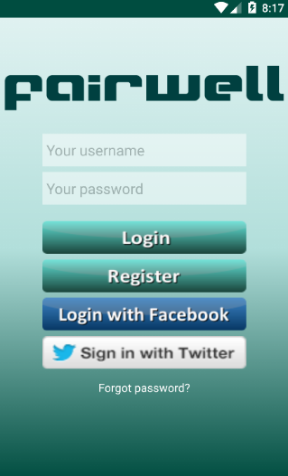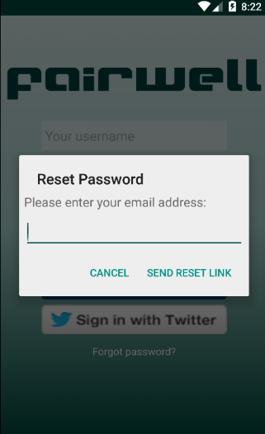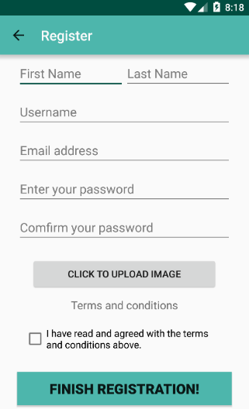

**To-do list:**

1. Write the “terms and condition”, display it using dialog box.
2. Implementation for “Click to upload image” will be same as “change profile picture” in account setting section.

# View statements

**To-do list:**

1. It will be a list of statements with date of event, event name and amount due. The amount due will be just yours to the payer. When clicking into the statement item, you can see more details such as types of event, mode, deadline, members, and snapshot.

# Add statement

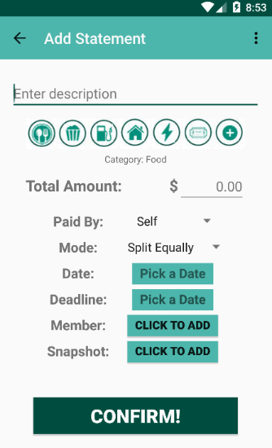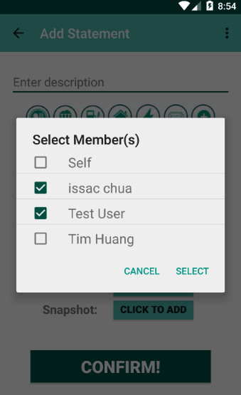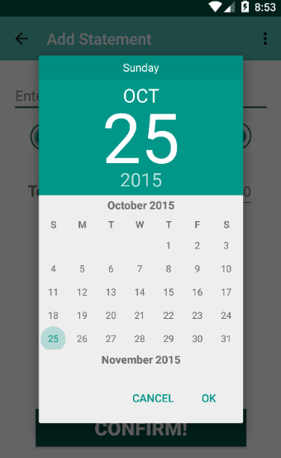

You can type the name of the statement, select the type of event, total amount of expenses, who pay for the event, how to split the expenses, date of event, deadline for the payment, members who are in the event, and snapshot of the receipt. The middle snapshot shows the calendar when clicking “Pick a date” and the rightmost snapshot shows the dialog of selecting members when clicking “click to add”.

**To-do list:**

1. When selecting the type of event, a darker icon should be displayed to indicate the type of event has been chosen. Only one of the icons should be selected at a time. The last icon – which is a plus sign, is used for users to add new event or select pre-existing event that is not on the screen.
2. We should discuss how we are going to handle different modes of payment.
3. Snapshot needs to be implemented – accessing to camera and then taking a photo. Display the photo underneath and allow the user to retake. (Turn the “click to add” button into the image, and click the image again to retake?)
4. Before sending out the notifications to every party member, the user will come to a summary page about such statement, “OK” to confirm the statement and “Cancel” to decline the statement.
5. The party member will receive the notification, when they click the notification, it will launch the Fairwell (if not opened) and display the statement, clicking “OK” to confirm the statement and “Cancel” to decline the statement. In both cases, the sender will receive their responses whether they accept or decline.

# resolve statements

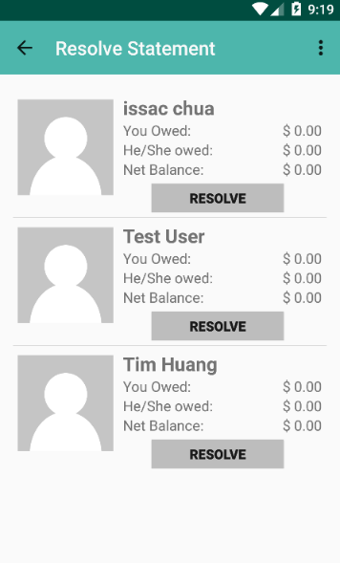“Resolve statements” is person-to-person based. Meaning, if you owe A or A owes you, A will be displayed in this section. Clicking “resolve” button will bring us to payment section (not yet implemented). If the statement is resolved, Fairwell will send notification to you and the person.

**To-do list:**

1. If the amount due is $0, then the person should not be displayed.
2. List should be sorted alphabetically.
3. Implement the payment option (which the amount will be filled in automatically)
4. Pondering: Only the one who owes more money can resolve the statement? If that is the case, “resolve” button should be disabled for the person who owes lesser.